**Lesson 06 Demo 03**

**Analyzing and Optimizing Existing Code Using Generative AI**

**Objective:** To analyze and enhance the time complexity of the codebase used in the Expressgo parcel delivery system by leveraging GitHub Copilot

**Tools required:** Visual Studio, GitHub Copilot, and POSTMAN

**Prerequisites:** refer expressgo code

Steps to be followed:

1. Analyze and optimize the existing code using GitHub Copilot

**Note:** Generative AI tool used in this exercise can produce varied outputs even when presented with similar prompts. Thus, you may get different output for the same prompt.

1. Verify the optimized code

**Step 1: Analyze and optimize the existing code using GitHub Copilot**

* 1. Download the **expressgo** zip file provided in the LMS and create a folder structure on the local drive, as shown below:

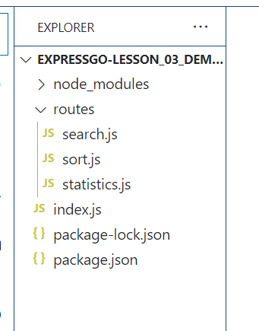

This project is base upon express js module running on port number 3000. Which provide 3 End Point as

<http://localhost:3000/sort>

This end is use to do sorting by default ascending. If need desending order we need to pass order as desc.

<http://localhost:3000/search>

This end point is use to search the particular value present in array or not.

<http://localhost:3000/statistics>

This end point is use to find mean, median and mode (the element occurs more than one time)

* 1. Navigate to the **expressgo-lesson_06_demo_03** folder and execute the command as **npm install**. Which is use to installed all required dependencies.
  2. Then open this folder in VS code and run the index.js file using below command as

**node index.js**

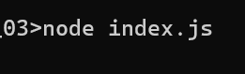



**Note:** Refer to Lesson 05 Demo 02, on how to utilize the Postman application for GET and POST requests to send and receive data. Ensure that the Python code in Visual Studio is running while you perform GET and POST methods using Postman.

* 1. Open the POSTMAN application, select the **POST method** in drop downoption,

<http://127.0.0.1:5000/sort>. Then select body part option and sub option as raw. In Text area you need to pass the data.

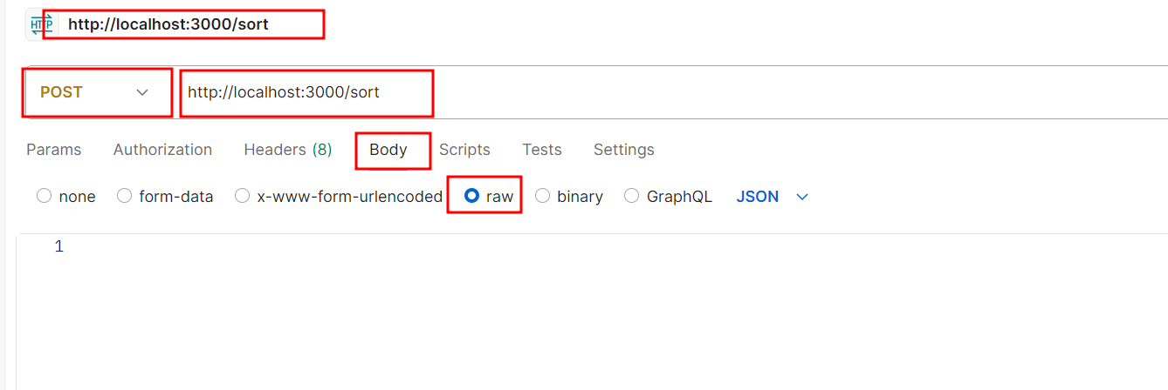

**{"numbers":[ 1000001008, 1000001009, 1000001013, 1000001014, 1000001015, 1000001027, 1000001028, 1000001029, 1000001030, 1000001031, 1000001032, 1000001035, 1000001042, 1000001043, 1000001045, 1000001047, 1000001053, 1000001056, 1000001057, 1000001058, 1000001061, 1000001063, 1000001066, 1000001067, 1000001074, 1000001077, 1000001078, 1000001079, 1000001082, 1000001083, 1000001084, 1000001087, 1000001089, 1000001091, 1000001092, 1000001093, 1000001095, 1000001096, 1000001101, 1000001102, 1000001103, 1000001105, 1000001109, 1000001111, 1000001114, 1000001117, 1000001118, 1000001119, 1000001120, 1000001121, 1000001122, 1000001124, 1000001126, 1000001127, 1000001130, 1000001132, 1000001133, 1000001134, 1000001135, 1000001137, 1000001142, 1000001144, 1000001145, 1000001150, 1000001153, 1000001154, 1000001157, 1000001159, 1000001162, 1000001166, 1000001167, 1000001168, 1000001169, 1000001170, 1000001173, 1000001175, 1000001176, 1000001179, 1000001180, 1000001186, 1000001187, 1000001188, 1000001189, 1000001196, 1000001198, 1000001199, 1000001201, 1000001203, 1000001204, 1000001210, 1000001212, 1000001216, 1000001217, 1000001219, 1000001222, 1000001223, 1000001224, 1000001225, 1000001231, 1000001232, 1000001234, 1000001235, 1000001237, 1000001239, 1000001242, 1000001246, 1000001249, 1000001250]}**

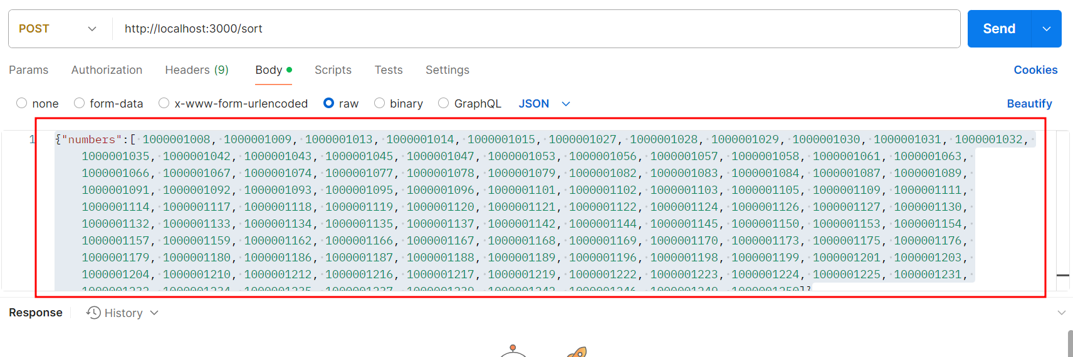

Now click on send buton.

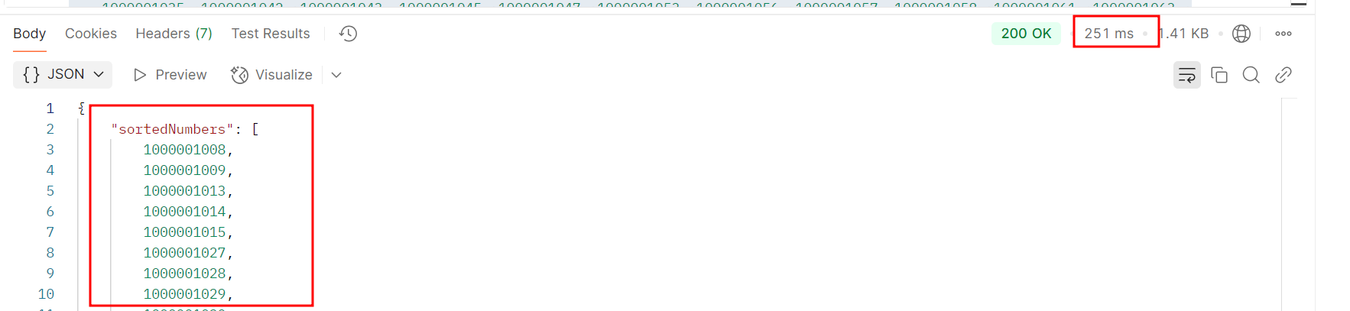

By default asending order. If you need descending order then.

Sample data

{"numbers":[ 1000001008, 1000001009, 1000001013, 1000001014, 1000001015, 1000001027, 1000001028, 1000001029, 1000001030, 1000001031, 1000001032, 1000001035, 1000001042, 1000001043, 1000001045, 1000001047, 1000001053, 1000001056, 1000001057, 1000001058, 1000001061, 1000001063, 1000001066, 1000001067, 1000001074, 1000001077, 1000001078, 1000001079, 1000001082, 1000001083, 1000001084, 1000001087, 1000001089, 1000001091, 1000001092, 1000001093, 1000001095, 1000001096, 1000001101, 1000001102, 1000001103, 1000001105, 1000001109, 1000001111, 1000001114, 1000001117, 1000001118, 1000001119, 1000001120, 1000001121, 1000001122, 1000001124, 1000001126, 1000001127, 1000001130, 1000001132, 1000001133, 1000001134, 1000001135, 1000001137, 1000001142, 1000001144, 1000001145, 1000001150, 1000001153, 1000001154, 1000001157, 1000001159, 1000001162, 1000001166, 1000001167, 1000001168, 1000001169, 1000001170, 1000001173, 1000001175, 1000001176, 1000001179, 1000001180, 1000001186, 1000001187, 1000001188, 1000001189, 1000001196, 1000001198, 1000001199, 1000001201, 1000001203, 1000001204, 1000001210, 1000001212, 1000001216, 1000001217, 1000001219, 1000001222, 1000001223, 1000001224, 1000001225, 1000001231, 1000001232, 1000001234, 1000001235, 1000001237, 1000001239, 1000001242, 1000001246, 1000001249, 1000001250],"order":"desc"}

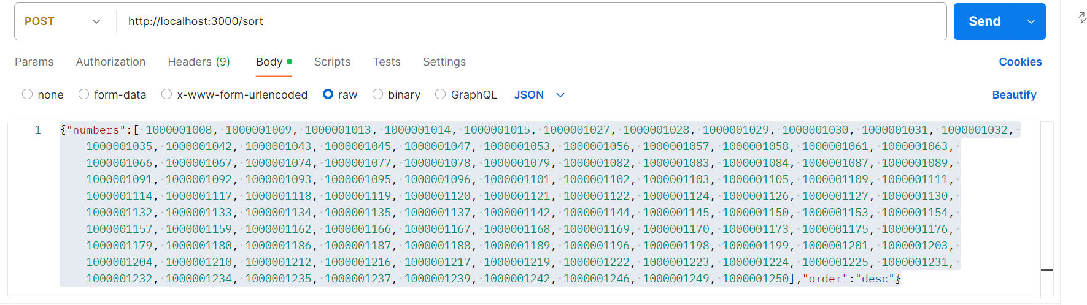

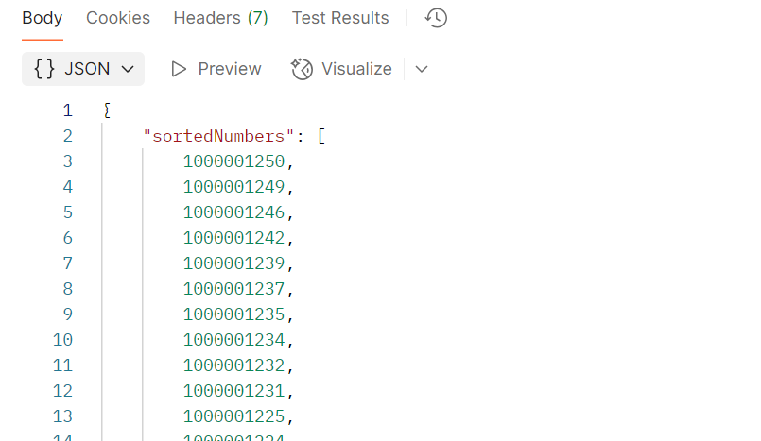

* 1. Provide the search API as **target: 1000001101** key value pairs to check element present **target:1234** element is not present.

Sample data

{"numbers":[ 1000001008, 1000001009, 1000001013, 1000001014, 1000001015, 1000001027, 1000001028, 1000001029, 1000001030, 1000001031, 1000001032, 1000001035, 1000001042, 1000001043, 1000001045, 1000001047, 1000001053, 1000001056, 1000001057, 1000001058, 1000001061, 1000001063, 1000001066, 1000001067, 1000001074, 1000001077, 1000001078, 1000001079, 1000001082, 1000001083, 1000001084, 1000001087, 1000001089, 1000001091, 1000001092, 1000001093, 1000001095, 1000001096, 1000001101, 1000001102, 1000001103, 1000001105, 1000001109, 1000001111, 1000001114, 1000001117, 1000001118, 1000001119, 1000001120, 1000001121, 1000001122, 1000001124, 1000001126, 1000001127, 1000001130, 1000001132, 1000001133, 1000001134, 1000001135, 1000001137, 1000001142, 1000001144, 1000001145, 1000001150, 1000001153, 1000001154, 1000001157, 1000001159, 1000001162, 1000001166, 1000001167, 1000001168, 1000001169, 1000001170, 1000001173, 1000001175, 1000001176, 1000001179, 1000001180, 1000001186, 1000001187, 1000001188, 1000001189, 1000001196, 1000001198, 1000001199, 1000001201, 1000001203, 1000001204, 1000001210, 1000001212, 1000001216, 1000001217, 1000001219, 1000001222, 1000001223, 1000001224, 1000001225, 1000001231, 1000001232, 1000001234, 1000001235, 1000001237, 1000001239, 1000001242, 1000001246, 1000001249, 1000001250],"target":1000001101}

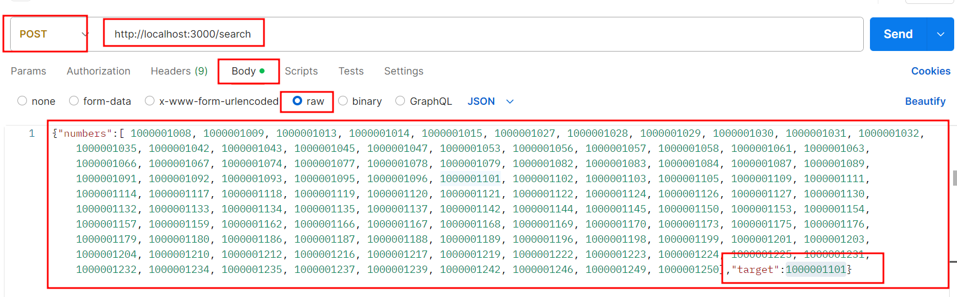

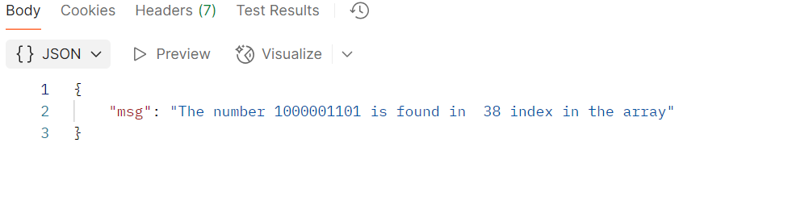

{"numbers":[ 1000001008, 1000001009, 1000001013, 1000001014, 1000001015, 1000001027, 1000001028, 1000001029, 1000001030, 1000001031, 1000001032, 1000001035, 1000001042, 1000001043, 1000001045, 1000001047, 1000001053, 1000001056, 1000001057, 1000001058, 1000001061, 1000001063, 1000001066, 1000001067, 1000001074, 1000001077, 1000001078, 1000001079, 1000001082, 1000001083, 1000001084, 1000001087, 1000001089, 1000001091, 1000001092, 1000001093, 1000001095, 1000001096, 1000001101, 1000001102, 1000001103, 1000001105, 1000001109, 1000001111, 1000001114, 1000001117, 1000001118, 1000001119, 1000001120, 1000001121, 1000001122, 1000001124, 1000001126, 1000001127, 1000001130, 1000001132, 1000001133, 1000001134, 1000001135, 1000001137, 1000001142, 1000001144, 1000001145, 1000001150, 1000001153, 1000001154, 1000001157, 1000001159, 1000001162, 1000001166, 1000001167, 1000001168, 1000001169, 1000001170, 1000001173, 1000001175, 1000001176, 1000001179, 1000001180, 1000001186, 1000001187, 1000001188, 1000001189, 1000001196, 1000001198, 1000001199, 1000001201, 1000001203, 1000001204, 1000001210, 1000001212, 1000001216, 1000001217, 1000001219, 1000001222, 1000001223, 1000001224, 1000001225, 1000001231, 1000001232, 1000001234, 1000001235, 1000001237, 1000001239, 1000001242, 1000001246, 1000001249, 1000001250],"target":12345}

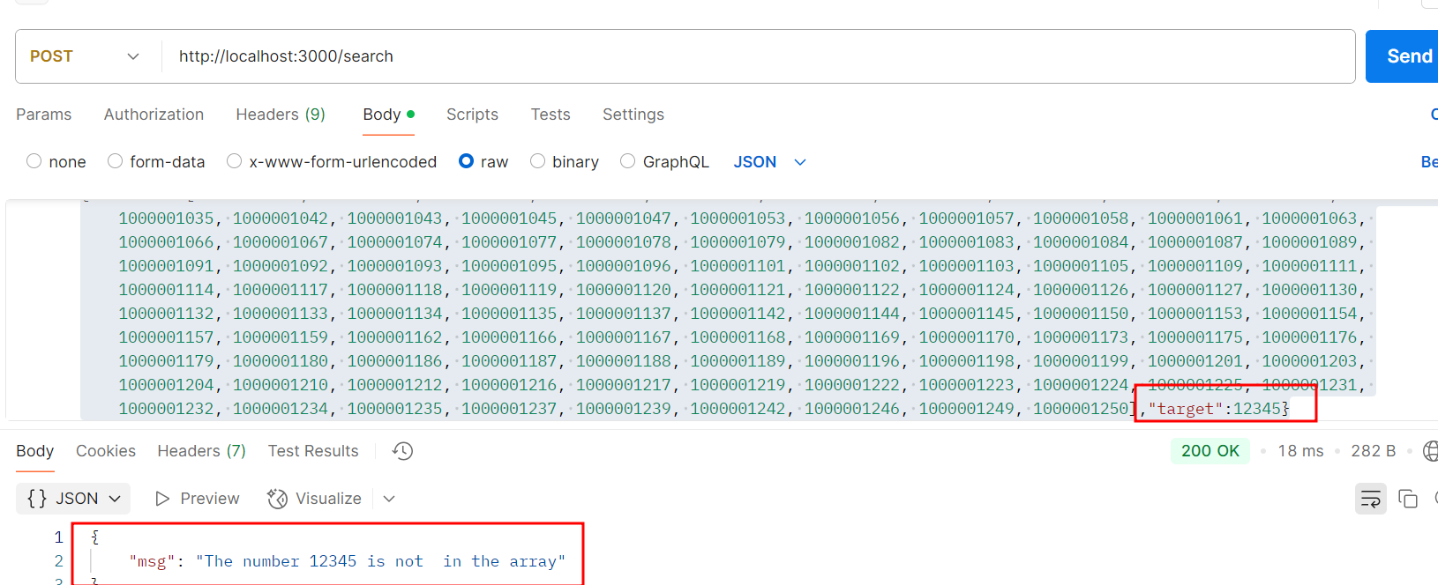

* 1. Open the **POSTMAN** application, select **POST**, and provide the following link to calculate statistics such as mean, median, and mode of the provided list of numbers:

[**http://localhost:3000/statistics**](http://localhost:3000/statistics)

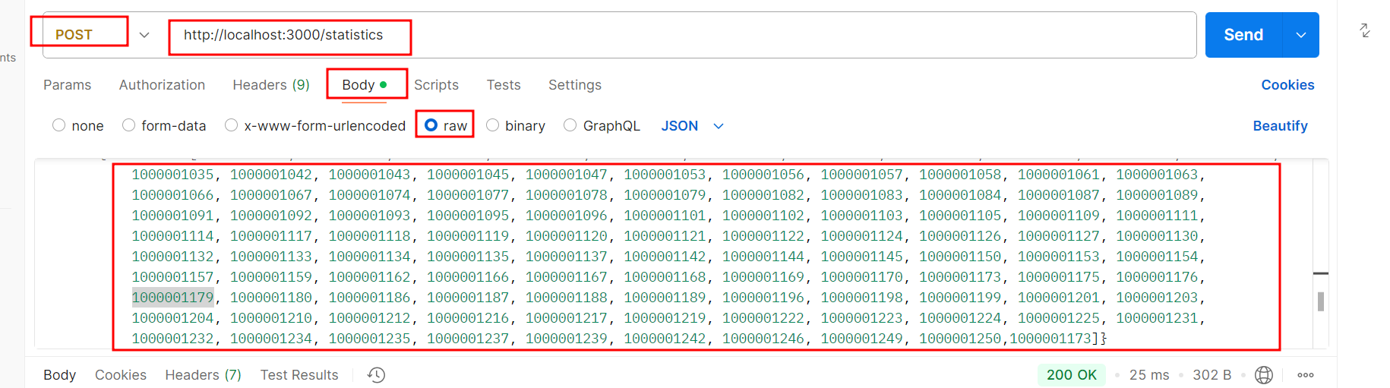

* 1. Provide the following data under **raw** with JSON option

**{"numbers":[ 1000001008, 1000001009, 1000001013, 1000001014, 1000001015, 1000001027, 1000001028, 1000001029, 1000001030, 1000001031, 1000001032, 1000001035, 1000001042, 1000001043, 1000001045, 1000001047, 1000001053, 1000001056, 1000001057, 1000001058, 1000001061, 1000001063, 1000001066, 1000001067, 1000001074, 1000001077, 1000001078, 1000001079, 1000001082, 1000001083, 1000001084, 1000001087, 1000001089, 1000001091, 1000001092, 1000001093, 1000001095, 1000001096, 1000001101, 1000001102, 1000001103, 1000001105, 1000001109, 1000001111, 1000001114, 1000001117, 1000001118, 1000001119, 1000001120, 1000001121, 1000001122, 1000001124, 1000001126, 1000001127, 1000001130, 1000001132, 1000001133, 1000001134, 1000001135, 1000001137, 1000001142, 1000001144, 1000001145, 1000001150, 1000001153, 1000001154, 1000001157, 1000001159, 1000001162, 1000001166, 1000001167, 1000001168, 1000001169, 1000001170, 1000001173, 1000001175, 1000001176, 1000001179, 1000001180, 1000001186, 1000001187, 1000001188, 1000001189, 1000001196, 1000001198, 1000001199, 1000001201, 1000001203, 1000001204, 1000001210, 1000001212, 1000001216, 1000001217, 1000001219, 1000001222, 1000001223, 1000001224, 1000001225, 1000001231, 1000001232, 1000001234, 1000001235, 1000001237, 1000001239, 1000001242, 1000001246, 1000001249, 1000001250,1000001173]}**

This step provides the following output:

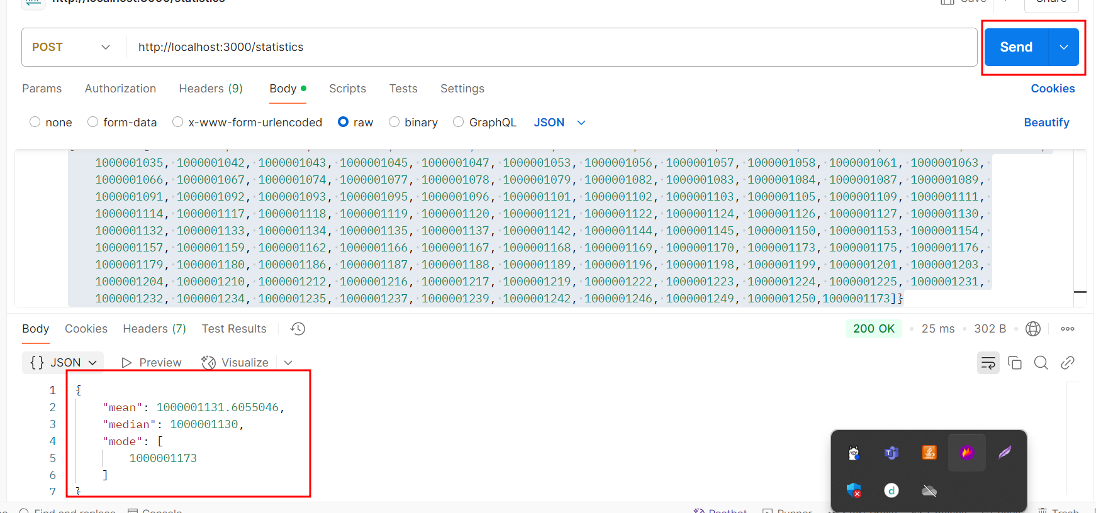

* 1. Enter the following prompt in GitHub Copilot to analyze the time complexity of this codebase:

**This workspace belongs to a parcel delivery company, ExpressGo. Analyze the time complexity for all APIs in this project.**



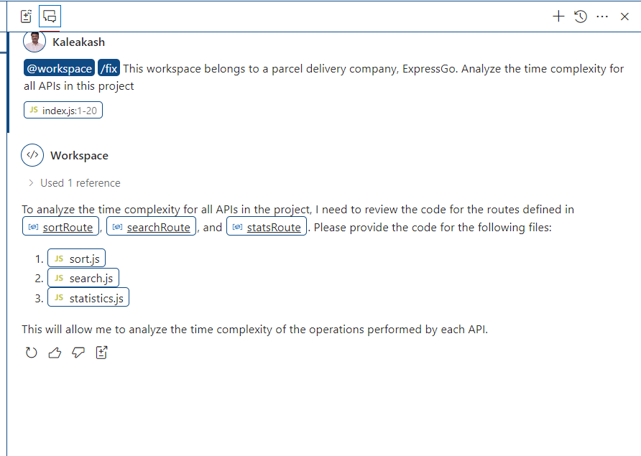

The time complexity for the sort.js file code.

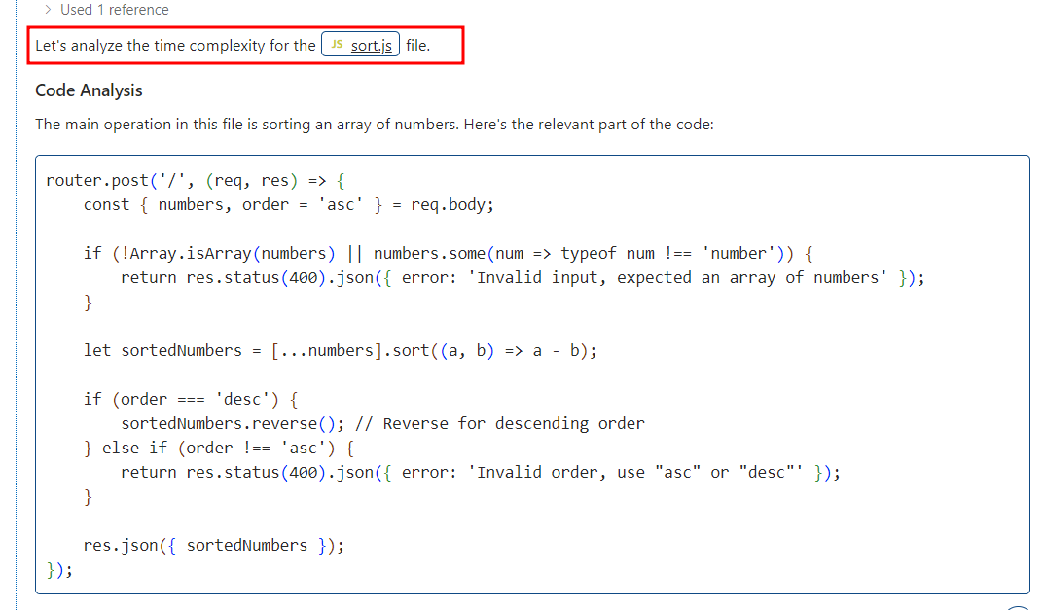

The time complexity for the search.js file code.

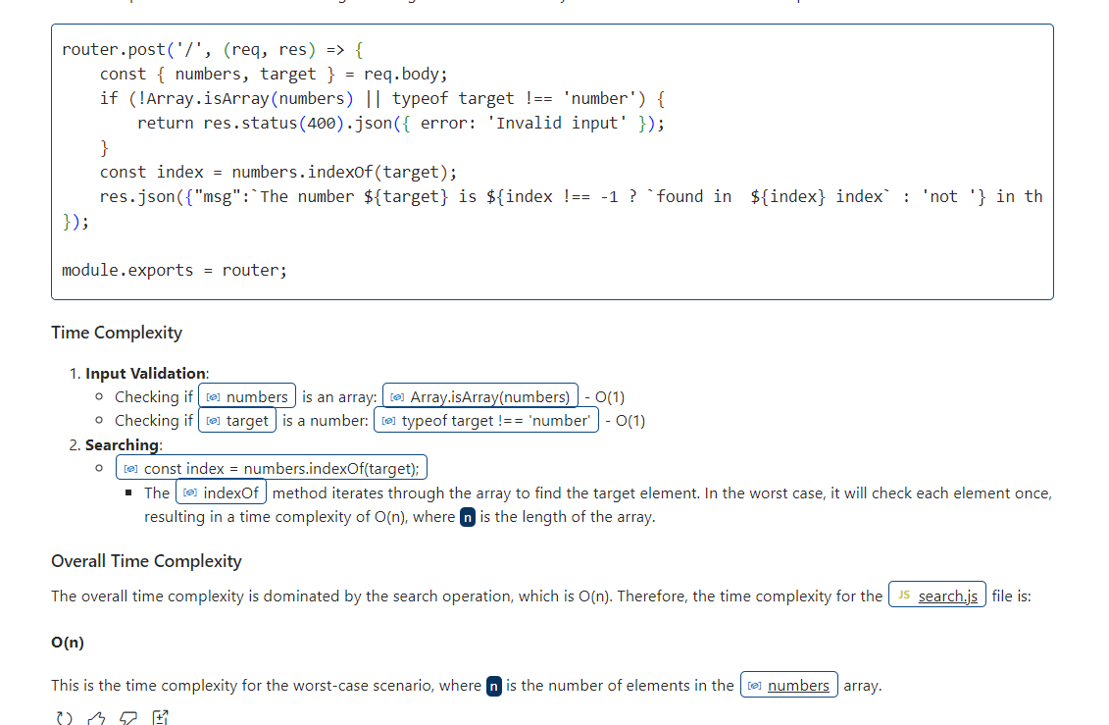

The time complexity for the statistics.js file code

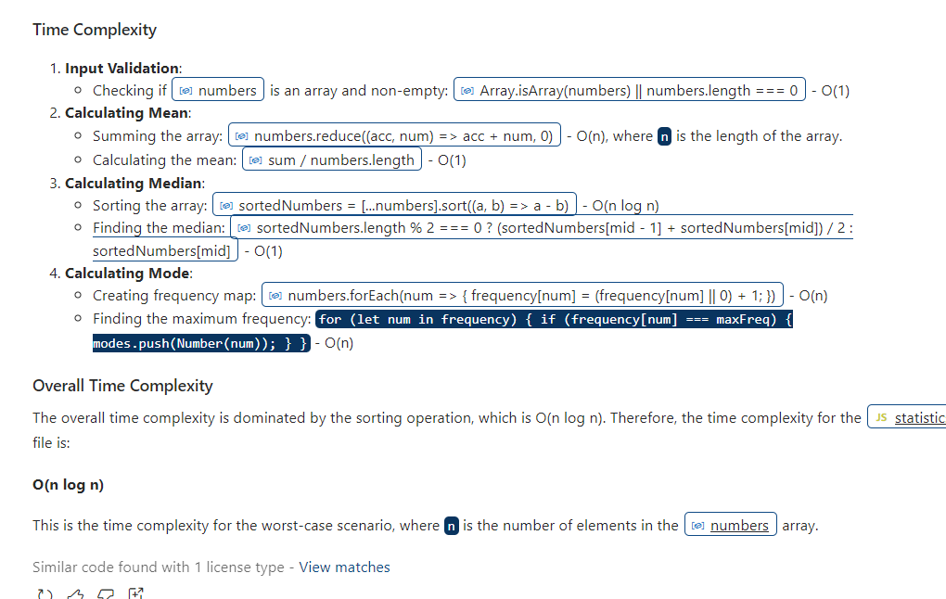

* 1. Enter the following prompt to optimize the codebase:

**Help me improve the time complexity for these APIs**

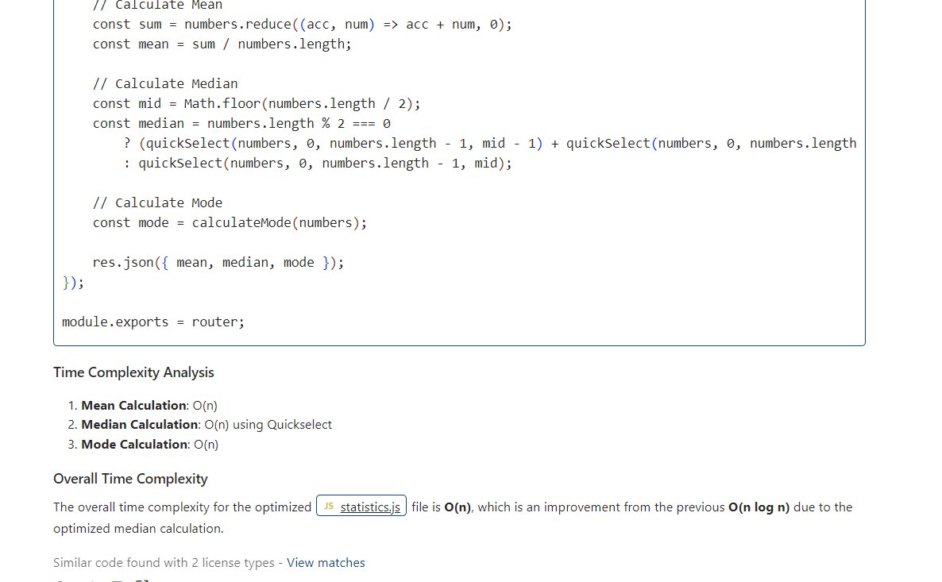

* 1. you can ask any suggestion from github copilot to improve the time complexity.

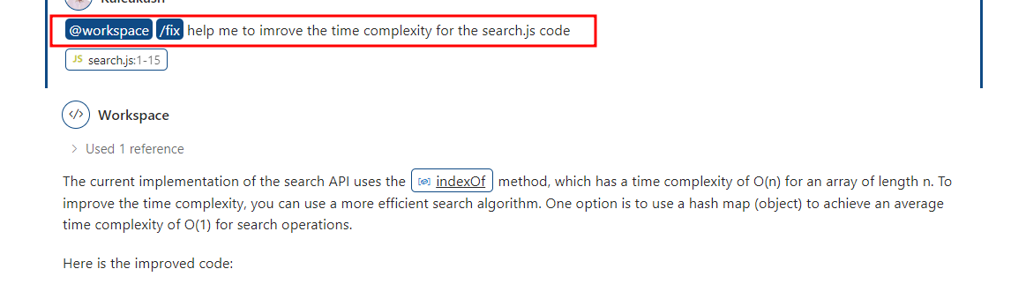

* 1. Check the search.js initial code with time taken to search the elements.

**search.js**

const express = require('express');

const router = express.Router();

router.post('/', (req, res) => {

    const { numbers, target } = req.body;

    if (!Array.isArray(numbers) || typeof target !== 'number') {

        return res.status(400).json({ error: 'Invalid input' });

    }

    const index = numbers.indexOf(target);

    res.json({"msg":`The number ${target} is ${index !== -1 ? `found in  ${index} index` : 'not '} in the array`});

    //res.json({ found: index !== -1, index });

});

module.exports = router;

* 1. send the request to search the particular element

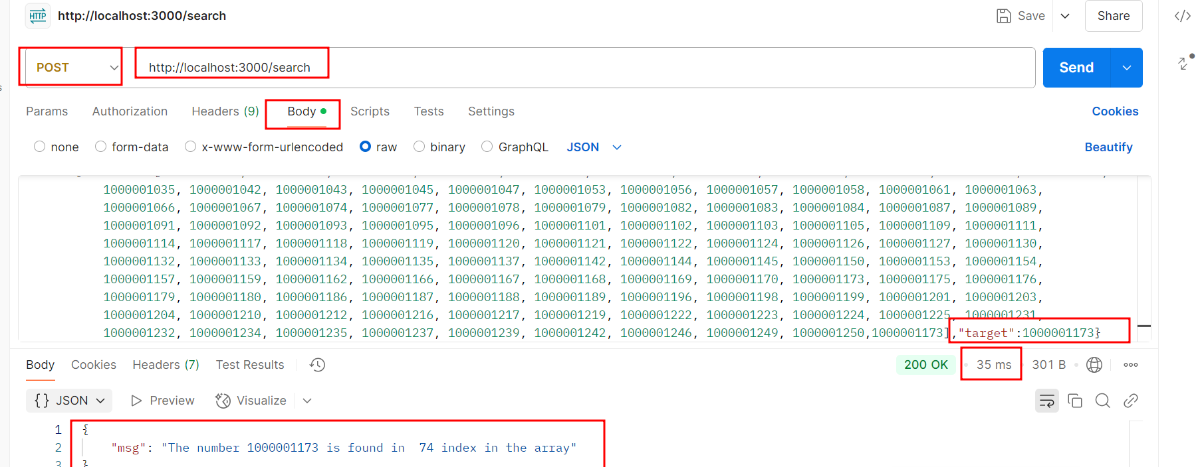

* 1. Now replace the new code provided by git hub copilot and stop and re-run the application and check the search time.

Search.js

const express = require('express');

const router = express.Router();

router.post('/', (req, res) => {

    const { numbers, target } = req.body;

    if (!Array.isArray(numbers) || typeof target !== 'number') {

        return res.status(400).json({ error: 'Invalid input' });

    }

    // Create a hash map to store the indices of the numbers

    const numMap = {};

    for (let i = 0; i < numbers.length; i++) {

        numMap[numbers[i]] = i;

    }

    // Check if the target number exists in the hash map

    const index = numMap[target];

    if (index !== undefined) {

        res.json({"msg":`The number ${target} is found in ${index} index`});

    } else {

        res.json({"msg":`The number ${target} is not in the array`});

    }

});

module.exports = router;

* 1. send the request to search the particular element

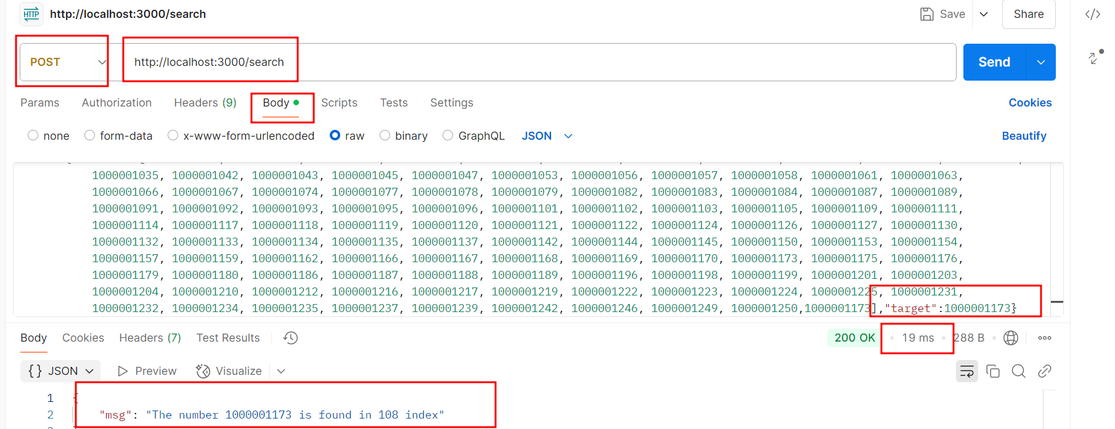

Here you can find the difference.

You can see the reduced time in the above output.

By following the outlined steps, you have successfully utilized generative AI To analyze and enhance the time complexity of the codebase used in the Expressgo parcel delivery system by leveraging GitHub Copilot to achieve significant improvements in efficiency and effectiveness.